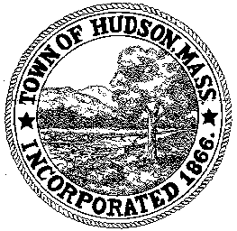

BOARD OF HEALTH
78 Main Street
Hudson, MA 01749
(978) 562-2020
Meeting Agenda
May 29, 2012
7:00 PM

- Preliminaries
1.1 Open Meeting
1.2 Roll Call

2.0 General Business
2.1 Election of Officers

2.2 Update on Community Transformation Grant

2.3 Update on Tobacco Control

2.4 Grant Application – Toxic Use Reduction

2.5 Grant Application – Creating a Database to Manage Special Populations

2.6 Discussion of the possibility of a full-time Assistant

3.0 Voucher BOH 052912

4.0 Adjournment

Next Meeting June 11, 2012

